SOFTWARE TESTING – TEST REPORT
Practical 15: Automated Login Testing of ParaBank
1. Test Report Information
Project Name | Automated Login Testing
Practical | Practical 15 – Tutorial 15
Application Under Test | ParaBank (https://parabank.parasoft.com/parabank/)
Module Tested | Authentication / Login
Test Type | Automated functional (authentication) testing, black box
Automation Script | P15.py
Executed By | Meshwa Prajapati
Execution Date | 03-10-2026 (started 07:49:39)
Overall Result | FAIL (4 of 6 test cases passed, 2 failed)
2. Aim
To create automated login functionality, authentication validation, assertions and exception handling scenarios using Selenium WebDriver with Python.
3. Application Under Test
ParaBank is a demo online banking website provided by Parasoft. Its home page contains a Customer Login form. A successful login opens the Accounts Overview page, which shows a welcome message and a Log Out link. A failed login should open an Error page with a message. The tests used the default demo customer (john / demo).
4. Test Environment
Parameter | Details
Operating System | Windows
Programming Language | Python 3.14.3
Automation Tool | Selenium WebDriver 4.49.0
Browser | Google Chrome 154.0.8037.93
IDE | PyCharm
Target URL | https://parabank.parasoft.com/parabank/index.htm
Test Data | Valid: john / demo  Invalid password: john / wrong_password  Invalid username: wrong_user / demo  Empty credentials: blank username and password
Execution approach | Each test case ran in its own new browser session
5. Login Scenarios
Test ID | Scenario | Expected Result
TC-15-01 | Valid Login | Login successful; Accounts Overview page opens with welcome message and Log Out link
TC-15-02 | Invalid Password | Error message displayed; user not logged in
TC-15-03 | Invalid Username | Error message displayed; user not logged in
TC-15-04 | Empty Credentials | Validation message displayed
TC-15-05 | Logout | User returns to the login page
TC-15-06 | Exception Handling Demonstration | Four Selenium exceptions are raised and handled
6. Test Case Execution
Results below are taken from the actual console output of P15.py.
Test ID | Scenario | Test Data | Expected Result | Actual Result | Status
TC-15-01 | Valid Login | john / demo | Accounts Overview page opens; welcome message and Log Out link shown | URL = https://parabank.parasoft.com/parabank/overview.htm, title = 'ParaBank | Accounts Overview', heading = 'Accounts Overview', welcome message and Log Out link displayed | PASS
TC-15-02 | Invalid Password | john / wrong_password | Error "The username and password could not be verified"; user not logged in | Accounts Overview page opened (URL https://parabank.parasoft.com/parabank/overview.htm, "Welcome John Smith" shown); no error message | FAIL
TC-15-03 | Invalid Username | wrong_user / demo | Error "The username and password could not be verified"; user not logged in | Accounts Overview page opened (URL https://parabank.parasoft.com/parabank/overview.htm, "Welcome John Smith" shown); no error message | FAIL
TC-15-04 | Empty Credentials | Blank / Blank | Validation message "Please enter a username and password" | Page = 'Error!', error shown: 'Please enter a username and password.' | PASS
TC-15-05 | Logout | john / demo, then Log Out | Login page ("Customer Login") displayed again | URL = https://parabank.parasoft.com/parabank/index.htm?ConnType=JDBC, login form displayed again (heading = 'Customer Login') | PASS
TC-15-06 | Exception Handling Demonstration | Deliberate faults | Four exceptions raised and handled | Handled: NoSuchElementException, TimeoutException, StaleElementReferenceException, ElementNotInteractableException | PASS
7. Error Message Validation
Scenario | Expected Message | Actual Message | Status
Empty credentials | Please enter a username and password | Please enter a username and password. | PASS
Invalid password | The username and password could not be verified | No error shown; Accounts Overview page opened | FAIL
Invalid username | The username and password could not be verified | No error shown; Accounts Overview page opened | FAIL
8. Assertion Validation
12 assertions passed during the run. They covered the following checks.
Assertion | Check | Test ID | Status
URL | URL contains overview.htm after valid login | TC-15-01 | PASS
Page heading / title | Heading "Accounts Overview" and title contain "Accounts Overview" | TC-15-01 | PASS
Welcome message | Welcome message shown in the left panel | TC-15-01 | PASS
Log Out link | Log Out link displayed after login | TC-15-01 | PASS
Error page and message | Error title and message shown for empty credentials | TC-15-04 | PASS
Login rejected | Account page not opened for invalid password / username | TC-15-02, 03 | FAIL
Logout | Login form and "Customer Login" heading shown after logout | TC-15-05 | PASS
9. Exception Handling
Exception | Cause Demonstrated | Handled | Where
NoSuchElementException | Locating an element that does not exist | Yes | TC-15-06
TimeoutException | Waiting 3 seconds for an element that never appears | Yes | TC-15-06
StaleElementReferenceException | Using an element after the page was refreshed | Yes | TC-15-06
ElementNotInteractableException | Typing into a hidden input field | Yes | TC-15-06
The script also catches these exceptions (and AssertionError and WebDriverException) in every test, so a problem in one test is reported as FAIL without stopping the others.
10. Execution Summary
Metric | Value
Total Test Cases | 6
Executed | 6
Passed | 4
Failed | 2 (TC-15-02, TC-15-03)
Pass Percentage | 66.7%
Assertions Passed | 12
Exceptions Handled | 4
Execution Time | 43.58 seconds
Overall Status | FAIL
11. Observations
Sr. No. | Observation
1 | Valid credentials (john / demo) authenticated the user and opened the Accounts Overview page.
2 | Defect observed: with an invalid password (john / wrong_password), ParaBank did not show an error. It opened the Accounts Overview page with "Welcome John Smith".
3 | Defect observed: with an invalid username (wrong_user / demo), ParaBank also opened the Accounts Overview page. This conflicts with the requirement that invalid credentials must be rejected.
4 | Empty credentials were correctly rejected with "Please enter a username and password."
5 | Logout returned the user to the login page.
6 | Each test ran in a new browser, and the previous run (07:46:28) showed the same behaviour, so it was not caused by a leftover session in the test. The cause was not investigated further; the tested website is a shared public demo.
12. Evidence
Insert the screenshots below before submission. The script also saved PR15_FAIL_TC-15-02.png and PR15_FAIL_TC-15-03.png in the project folder.
Figure 2: Login page
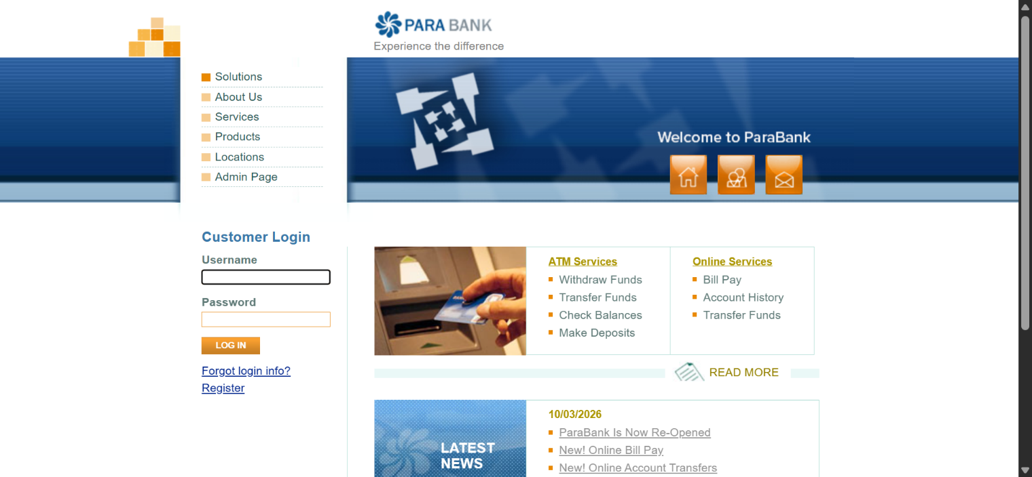
Figure 3: Valid login result (Accounts Overview)
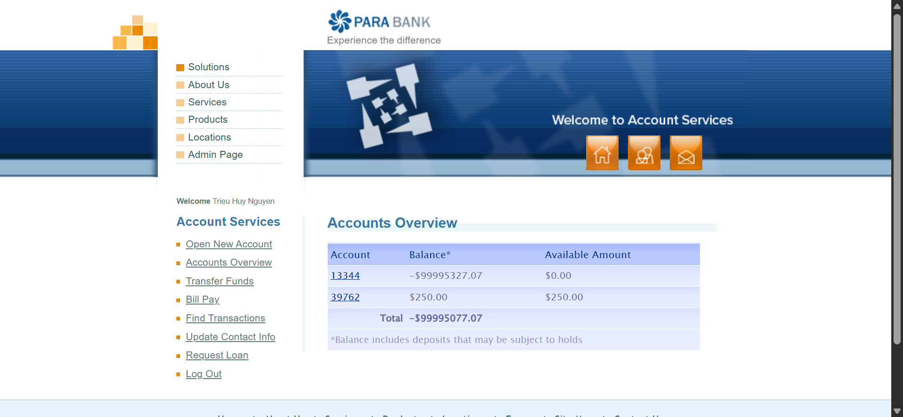
Figure 4: Invalid password result (PR15_FAIL_TC-15-02.png)
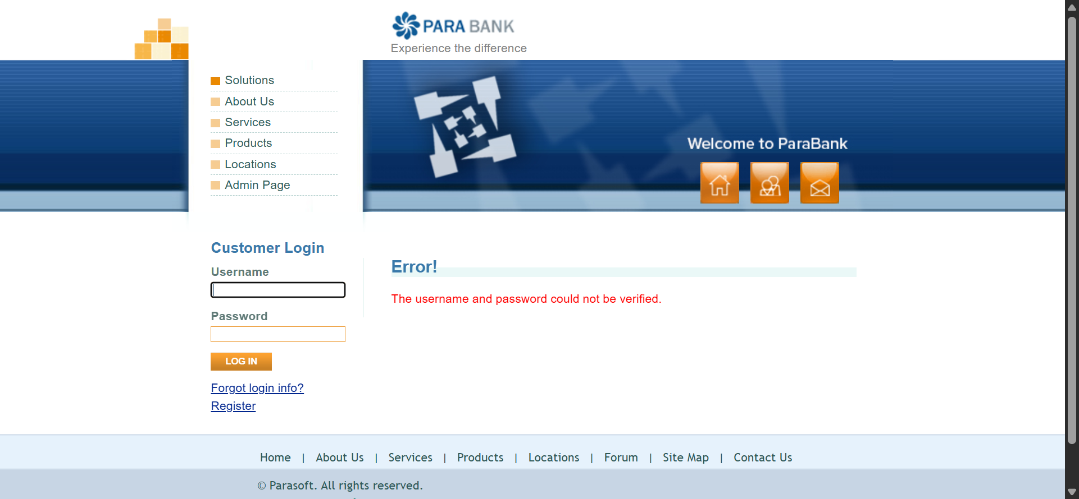
Figure 5: Invalid username result (PR15_FAIL_TC-15-03.png)
Figure 6: Empty credentials error message
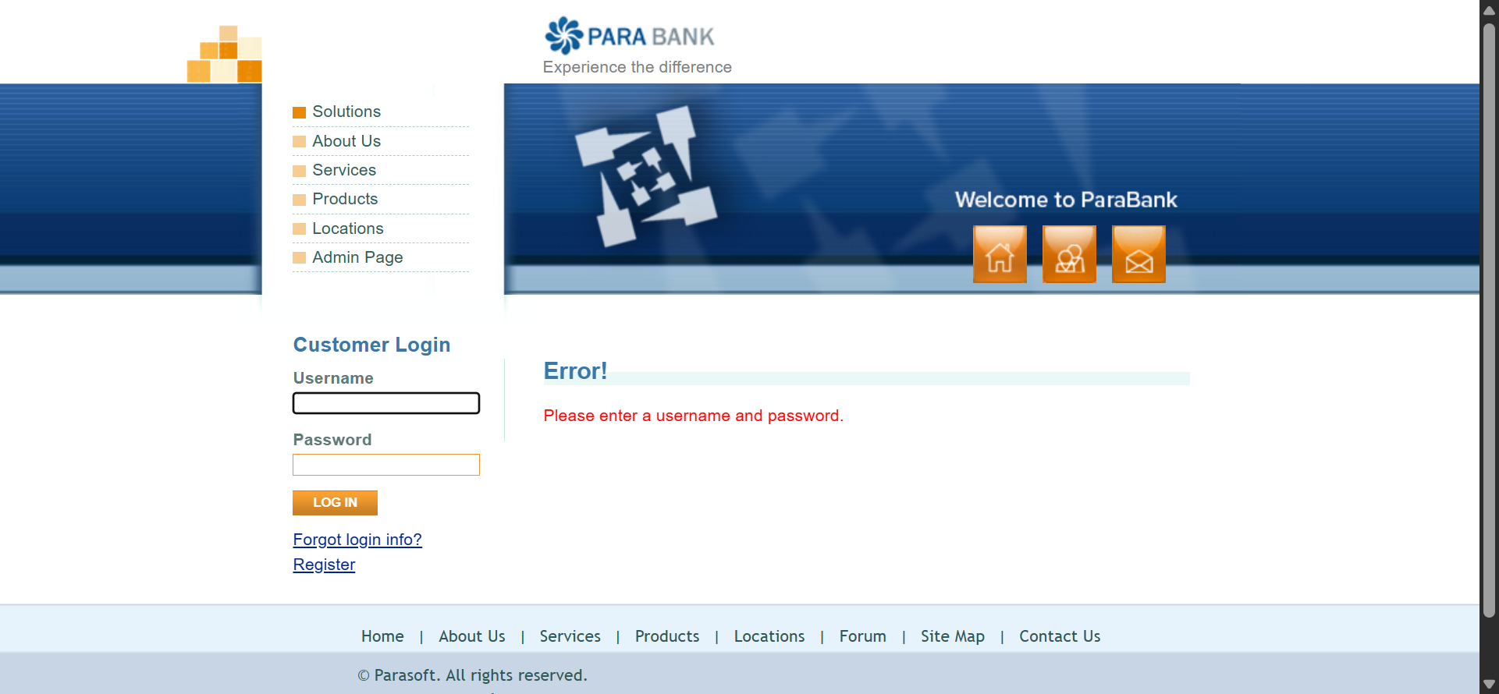
Figure 7: Logout result
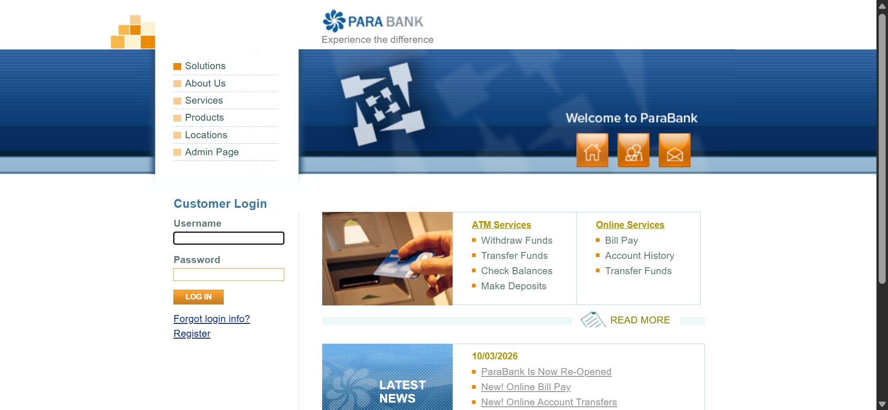
Appendix A: Console Output
======================================================================
Practical 15 - Automated Login Testing (ParaBank)
Execution started: 03-10-2026 07:49:39
======================================================================
Browser : chrome 154.0.8037.93
Selenium: 4.49.0
Python : 3.14.3
URL : https://parabank.parasoft.com/parabank/index.htm
Valid credentials used : john / demo

--- TC-15-01: Valid Login ---
Result : PASS
Detail : URL = https://parabank.parasoft.com/parabank/overview.htm, title = 'ParaBank | Accounts Overview', heading = 'Accounts Overview', welcome message and Log Out link displayed

--- TC-15-02: Invalid Password ---
Result : FAIL
Detail : Assertion failed: Application ACCEPTED the invalid credentials and opened the Accounts Overview page. URL = https://parabank.parasoft.com/parabank/overview.htm, title = 'ParaBank | Accounts Overview', page text = 'Experience the difference Solutions About Us Services Products Locations Admin Page home about contact Welcome John Smith Account Services Open New Account Accounts Overview Transfer Funds Bill Pay Find Transactions Update Contact Info Request Loan Log Out Accounts Overview Account Balance* Availabl' (screenshot saved: PR15_FAIL_TC-15-02.png)

--- TC-15-03: Invalid Username ---
Result : FAIL
Detail : Assertion failed: Application ACCEPTED the invalid credentials and opened the Accounts Overview page. URL = https://parabank.parasoft.com/parabank/overview.htm, title = 'ParaBank | Accounts Overview', page text = 'Experience the difference Solutions About Us Services Products Locations Admin Page home about contact Welcome John Smith Account Services Open New Account Accounts Overview Transfer Funds Bill Pay Find Transactions Update Contact Info Request Loan Log Out Accounts Overview Account Balance* Availabl' (screenshot saved: PR15_FAIL_TC-15-03.png)

--- TC-15-04: Empty Credentials ---
Result : PASS
Detail : Page = 'Error!', error shown: 'Please enter a username and password.'

--- TC-15-05: Logout ---
Result : PASS
Detail : URL = https://parabank.parasoft.com/parabank/index.htm?ConnType=JDBC, login form displayed again (heading = 'Customer Login')

--- TC-15-06: Exception Handling Demonstration ---
Handled: NoSuchElementException (element cannot be located)
Handled: TimeoutException (element did not appear within wait time)
Handled: StaleElementReferenceException (DOM changed after element was located)
Handled: ElementNotInteractableException (element cannot be interacted with)
Result : PASS
Detail : Handled: NoSuchElementException, TimeoutException, StaleElementReferenceException, ElementNotInteractableException

======================================================================
EXECUTION SUMMARY
======================================================================
TC-15-01 Valid Login PASS
TC-15-02 Invalid Password FAIL
TC-15-03 Invalid Username FAIL
TC-15-04 Empty Credentials PASS
TC-15-05 Logout PASS
TC-15-06 Exception Handling Demonstration PASS
----------------------------------------------------------------------
Total test cases : 6
Executed : 6
Passed : 4
Failed : 2
Assertions passed : 12
Exceptions handled : 4
Execution time : 43.58 seconds
Overall status : FAIL
======================================================================
Appendix B: Source Code (P15.py)
"""
Practical 15 - Automated Login Testing (Software Testing)
Application Under Test : ParaBank (https://parabank.parasoft.com/parabank/)
Tool / Language : Selenium WebDriver + Python (Google Chrome, PyCharm)

Covers: valid login, invalid password, invalid username, empty credentials,
authentication assertions, error-message validation, logout and exception
handling (including a demonstration of four common Selenium exceptions).

Every test case runs in a NEW browser session (like the tutorial), so the result
of one test can never affect another.

Test credentials: ParaBank's default demo customer john / demo
(if the public server no longer accepts them, register a user on the site and
change VALID_USERNAME / VALID_PASSWORD below).

Install : pip install selenium
Run : python PR15.py
"""

import sys
import time
from datetime import datetime

import selenium
from selenium import webdriver
from selenium.common.exceptions import (
ElementNotInteractableException,
NoSuchElementException,
StaleElementReferenceException,
TimeoutException,
WebDriverException,
)
from selenium.webdriver.common.by import By
from selenium.webdriver.support import expected_conditions as EC
from selenium.webdriver.support.ui import WebDriverWait

# --------------------------------------------------------------------------
# Test data
# --------------------------------------------------------------------------
URL = "https://parabank.parasoft.com/parabank/index.htm"
VALID_USERNAME = "john"
VALID_PASSWORD = "demo"
INVALID_USERNAME = "wrong_user"
INVALID_PASSWORD = "wrong_password"

MSG_NOT_VERIFIED = "The username and password could not be verified"
MSG_EMPTY = "Please enter a username and password"

# --------------------------------------------------------------------------
# Locators
# --------------------------------------------------------------------------
USERNAME = (By.NAME, "username")
PASSWORD = (By.NAME, "password")
LOGIN_BTN = (By.CSS_SELECTOR, "input[value='Log In']")
LOGIN_HEADING = (By.CSS_SELECTOR, "#leftPanel h2")
PAGE_HEADING = (By.CSS_SELECTOR, "h1.title")
ERROR_MSG = (By.CSS_SELECTOR, "p.error")
LEFT_PANEL = (By.ID, "leftPanel")
LOGOUT_LINK = (By.CSS_SELECTOR, "#leftPanel a[href*='logout.htm']")

# --------------------------------------------------------------------------
# Shared state, counters and results
# --------------------------------------------------------------------------
ctx = {"driver": None, "wait": None}
counters = {"assertions": 0, "exceptions": 0}
results = [] # (test_id, scenario, status, detail)

def check(condition, message):
"""Assertion helper: counts passed assertions and raises AssertionError on failure."""
assert condition, message
counters["assertions"] += 1

def run_test(test_id, scenario, func):
"""Run one test case in its own new browser, handle exceptions, print and record the outcome."""
print(f"\n--- {test_id}: {scenario} ---")
ctx["driver"] = None
try:
ctx["driver"] = build_driver()
ctx["wait"] = WebDriverWait(ctx["driver"], 20)
detail = func()
status = "PASS"
except AssertionError as err:
status, detail = "FAIL", f"Assertion failed: {err}"
except TimeoutException:
counters["exceptions"] += 1
status, detail = "FAIL", "TimeoutException handled: expected element/condition did not appear in time"
except NoSuchElementException as err:
counters["exceptions"] += 1
status, detail = "FAIL", f"NoSuchElementException handled: {err.msg}"
except ElementNotInteractableException as err:
counters["exceptions"] += 1
status, detail = "FAIL", f"ElementNotInteractableException handled: {err.msg}"
except StaleElementReferenceException as err:
counters["exceptions"] += 1
status, detail = "FAIL", f"StaleElementReferenceException handled: {err.msg}"
except WebDriverException as err:
counters["exceptions"] += 1
status, detail = "FAIL", f"WebDriverException handled: {str(err).splitlines()[0]}"

if status == "FAIL" and ctx["driver"] is not None:
try:
ctx["driver"].save_screenshot(f"PR15_FAIL_{test_id}.png")
detail += f" (screenshot saved: PR15_FAIL_{test_id}.png)"
except Exception:
pass
if ctx["driver"] is not None:
try:
ctx["driver"].quit()
except Exception:
pass
ctx["driver"] = None

results.append((test_id, scenario, status, detail))
print(f"Result : {status}")
print(f"Detail : {detail}")
return status == "PASS"

# --------------------------------------------------------------------------
# Helper functions
# --------------------------------------------------------------------------
def d():
return ctx["driver"]

def w():
return ctx["wait"]

def open_login_page():
"""Open the ParaBank home page (login form)."""
d().get(URL)
w().until(EC.visibility_of_element_located(USERNAME))

def login(username, password):
user_box = w().until(EC.visibility_of_element_located(USERNAME))
pass_box = w().until(EC.visibility_of_element_located(PASSWORD))
login_button = w().until(EC.element_to_be_clickable(LOGIN_BTN))
user_box.clear()
user_box.send_keys(username)
pass_box.clear()
pass_box.send_keys(password)
login_button.click()

def page_snapshot():
"""Short description of the current page, used in failure messages."""
try:
body = d().find_element(By.TAG_NAME, "body").text
except WebDriverException:
body = ""
body = " ".join(body.split())[:300]
return f"URL = {d().current_url}, title = '{d().title}', page text = '{body}'"

def verify_login_rejected(expected_message):
"""Common checks for every unsuccessful login attempt."""
try:
w().until(lambda drv: "Error" in drv.title or "overview.htm" in drv.current_url)
except TimeoutException:
raise AssertionError("Neither an error page nor the account page was displayed. " + page_snapshot())
if "overview.htm" in d().current_url:
raise AssertionError("Application ACCEPTED the invalid credentials and opened the Accounts Overview page. "
+ page_snapshot())
messages = d().find_elements(*ERROR_MSG)
if messages:
message = messages[0].text
else:
message = d().find_element(By.ID, "rightPanel").text
message = " ".join(message.split())
heading = d().find_element(*PAGE_HEADING).text
check(expected_message.lower() in message.lower(),
f"Expected '{expected_message}', found '{message}'")
check("Error" in d().title, f"Unexpected page title: {d().title}")
check("overview.htm" not in d().current_url, "User must not reach the Accounts Overview page")
return message, heading

# --------------------------------------------------------------------------
# Test cases
# --------------------------------------------------------------------------
def tc_valid_login():
open_login_page()
login(VALID_USERNAME, VALID_PASSWORD)
w().until(EC.url_contains("overview.htm"))
check("overview.htm" in d().current_url, f"Unexpected URL: {d().current_url}")
heading = w().until(EC.visibility_of_element_located(PAGE_HEADING)).text
check("accounts overview" in heading.lower(), f"Unexpected heading: {heading}")
check("Accounts Overview" in d().title, f"Unexpected page title: {d().title}")
panel = d().find_element(*LEFT_PANEL).text
check("Welcome" in panel, "Welcome message not displayed")
check(d().find_element(*LOGOUT_LINK).is_displayed(), "Log Out link not displayed")
return f"URL = {d().current_url}, title = '{d().title}', heading = '{heading}', welcome message and Log Out link displayed"

def tc_invalid_password():
open_login_page()
login(VALID_USERNAME, INVALID_PASSWORD)
message, heading = verify_login_rejected(MSG_NOT_VERIFIED)
return f"Page = '{heading}', error shown: '{message}'"

def tc_invalid_username():
open_login_page()
login(INVALID_USERNAME, VALID_PASSWORD)
message, heading = verify_login_rejected(MSG_NOT_VERIFIED)
return f"Page = '{heading}', error shown: '{message}'"

def tc_empty_credentials():
open_login_page()
w().until(EC.element_to_be_clickable(LOGIN_BTN)).click()
message, heading = verify_login_rejected(MSG_EMPTY)
return f"Page = '{heading}', error shown: '{message}'"

def tc_logout():
open_login_page()
login(VALID_USERNAME, VALID_PASSWORD)
w().until(EC.url_contains("overview.htm"))
w().until(EC.element_to_be_clickable(LOGOUT_LINK)).click()
w().until(EC.visibility_of_element_located(USERNAME))
heading = d().find_element(*LOGIN_HEADING).text
check("customer login" in heading.lower(), f"Unexpected heading after logout: {heading}")
check("overview.htm" not in d().current_url, "User should have left the Accounts Overview page")
check(d().find_element(*LOGIN_BTN).is_displayed(), "Login form should be displayed after logout")
return f"URL = {d().current_url}, login form displayed again (heading = '{heading}')"

def tc_exception_handling():
"""
Demonstrates handling of four common Selenium exceptions.
Each fault is created on purpose; the test passes only if the expected
exception is raised AND handled by the script.
"""
open_login_page()
handled = []

# 1. NoSuchElementException - locate an element that does not exist
try:
d().find_element(By.ID, "element-that-does-not-exist")
check(False, "NoSuchElementException was expected")
except NoSuchElementException:
counters["exceptions"] += 1
handled.append("NoSuchElementException")
print(" Handled: NoSuchElementException (element cannot be located)")

# 2. TimeoutException - wait for an element that never appears
try:
WebDriverWait(d(), 3).until(
EC.visibility_of_element_located((By.ID, "element-that-never-appears")))
check(False, "TimeoutException was expected")
except TimeoutException:
counters["exceptions"] += 1
handled.append("TimeoutException")
print(" Handled: TimeoutException (element did not appear within wait time)")

# 3. StaleElementReferenceException - use an element after the page was reloaded
old_box = d().find_element(*USERNAME)
d().refresh()
w().until(EC.visibility_of_element_located(USERNAME))
try:
old_box.send_keys("text")
check(False, "StaleElementReferenceException was expected")
except StaleElementReferenceException:
counters["exceptions"] += 1
handled.append("StaleElementReferenceException")
print(" Handled: StaleElementReferenceException (DOM changed after element was located)")

# 4. ElementNotInteractableException - type into an element that is hidden
hidden_box = d().find_element(*USERNAME)
d().execute_script("arguments[0].style.display = 'none';", hidden_box)
try:
hidden_box.send_keys("text")
check(False, "ElementNotInteractableException was expected")
except ElementNotInteractableException:
counters["exceptions"] += 1
handled.append("ElementNotInteractableException")
print(" Handled: ElementNotInteractableException (element cannot be interacted with)")

check(len(handled) == 4, f"Only {len(handled)} of 4 exceptions were handled")
return "Handled: " + ", ".join(handled)

# --------------------------------------------------------------------------
# Driver and reporting
# --------------------------------------------------------------------------
def build_driver():
options = webdriver.ChromeOptions()
# Stops Chrome password-manager / breach pop-ups from interfering with the test
options.add_experimental_option("prefs", {
"credentials_enable_service": False,
"profile.password_manager_enabled": False,
"profile.password_manager_leak_detection": False,
})
options.add_experimental_option("excludeSwitches", ["enable-automation"])
driver = webdriver.Chrome(options=options)
driver.maximize_window()
driver.set_page_load_timeout(60)
return driver

def print_summary(elapsed):
total = len(results)
passed = sum(1 for r in results if r[2] == "PASS")
failed = total - passed
print("\n" + "=" * 70)
print("EXECUTION SUMMARY")
print("=" * 70)
for test_id, scenario, status, _ in results:
print(f"{test_id:<10} {scenario:<50} {status}")
print("-" * 70)
print(f"Total test cases : {len(results)}")
print(f"Executed : {total}")
print(f"Passed : {passed}")
print(f"Failed : {failed}")
print(f"Assertions passed : {counters['assertions']}")
print(f"Exceptions handled : {counters['exceptions']}")
print(f"Execution time : {elapsed:.2f} seconds")
print(f"Overall status : {'PASS' if failed == 0 and total > 0 else 'FAIL'}")
print("=" * 70)

def main():
print("=" * 70)
print("Practical 15 - Automated Login Testing (ParaBank)")
print(f"Execution started: {datetime.now():%d-%m-%Y %H:%M:%S}")
print("=" * 70)

start = time.time()
try:
probe = build_driver()
caps = probe.capabilities
print(f"Browser : {caps.get('browserName')} {caps.get('browserVersion')}")
probe.quit()
print(f"Selenium: {selenium.__version__}")
print(f"Python : {sys.version.split()[0]}")
print(f"URL : {URL}")
print(f"Valid credentials used : {VALID_USERNAME} / {VALID_PASSWORD}")

run_test("TC-15-01", "Valid Login", tc_valid_login)
run_test("TC-15-02", "Invalid Password", tc_invalid_password)
run_test("TC-15-03", "Invalid Username", tc_invalid_username)
run_test("TC-15-04", "Empty Credentials", tc_empty_credentials)
run_test("TC-15-05", "Logout", tc_logout)
run_test("TC-15-06", "Exception Handling Demonstration", tc_exception_handling)

except WebDriverException as err:
print(f"\nCRITICAL ERROR: could not start or continue the browser session.\n{err}")
finally:
print_summary(time.time() - start)

if __name__ == "__main__":
main()

